Rafael V. Canseco

09/15/24

SNHU: CS-340

Assignment 2-1: CRUD in MongoDB

1. A screenshot of a computer

   Description automatically generatedImporting Mongo utility:
2. Verifying your Load:
   1. 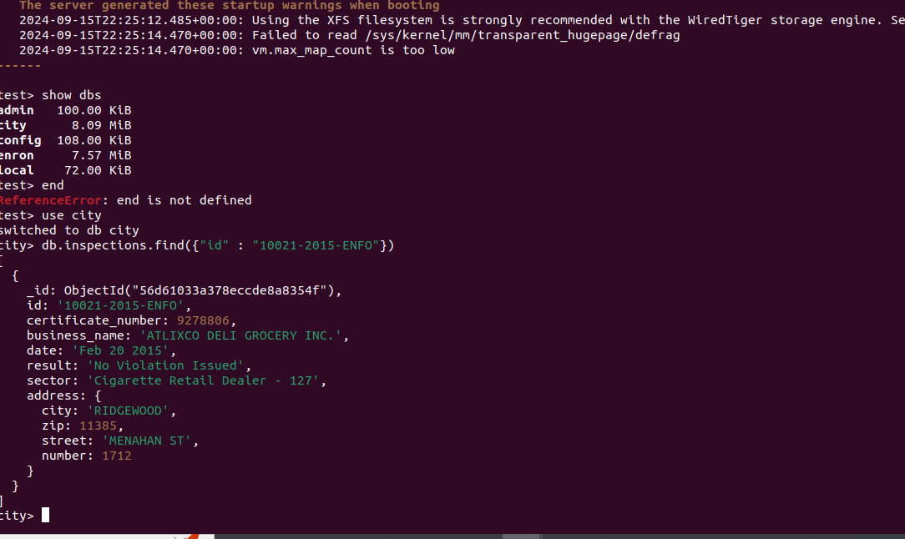

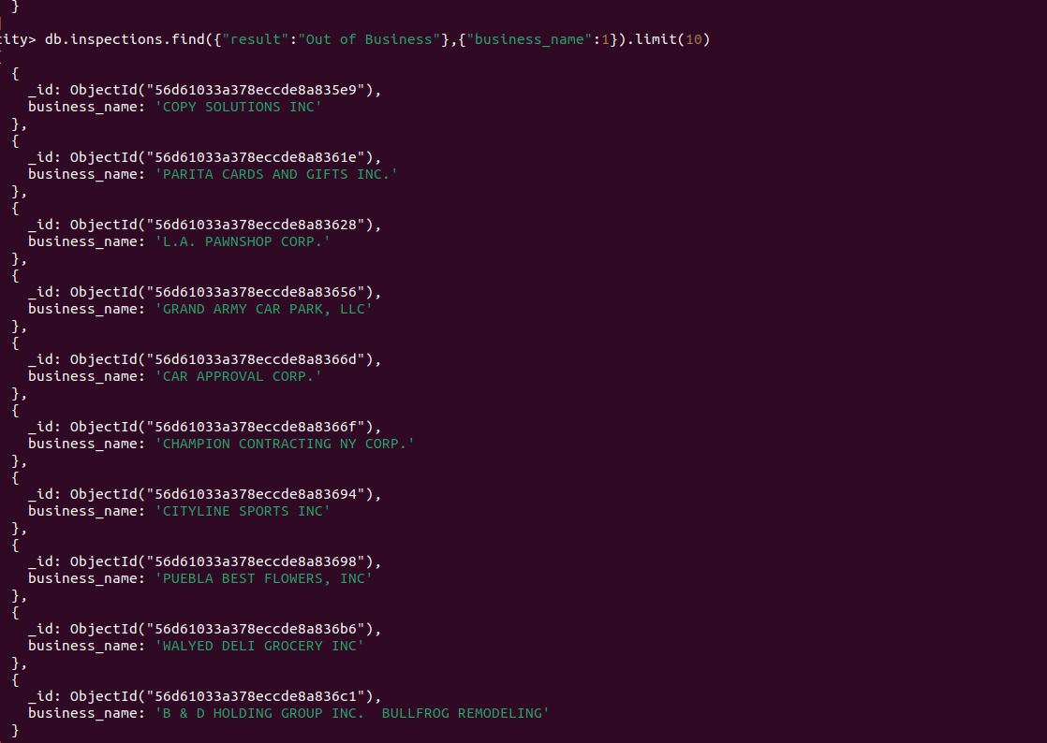

1. Inserting a document
   1. Adding Document:

* 1. Verifying inserted Document:

1. a. What is the distinct list of inspection “sector” in the current inspections collection? How many are in the list? Do not count by hand.A close-up of a computer screen

   Description automatically generated
2. What is the difference in the date data type for the business named “AUSTIN 2012” versus your business document insertion of “Acme Explosives”? "AUSTIN 2012": Date is stored as a string, and ACME Explosives": Date is stored as an ISODate object, which is a more appropriate format for date and time data.

1. How many businesses have a “Violation Issued”? (See **Value** column above.)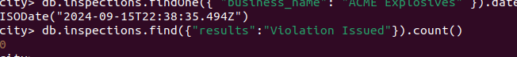
2. Before Update: A computer screen with white text

   Description automatically generated

After Update:

1. a. Update all the documents that contain the key-value pair "city":"ROSEDALE" in the address subdocument by changing the zip code in the address subdocument to "76114".

Removing:

